Sentiment Analysis Report

Purpose and Objective

The purpose of this project was to analyze the sentiment of tweets to understand public opinion on various topics. The objective was to scrape Twitter data, preprocess it using NLP techniques such as tokenization and lemmatization, and perform sentiment analysis with TextBlob. By extracting key words from tweets, the project aimed to refine sentiment scoring and provide insights into sentiment trends, including variations across users and topics.

**Key Findings**

1. **Overall Sentiment Score**:
   * The overall sentiment score derived from analyzing the tweets is **0.039**, suggesting a neutral to slightly positive sentiment trend.
2. **Sentiment Rankings (Full Text Analysis)**:
   * Ranking users based on the average sentiment score of their tweets:

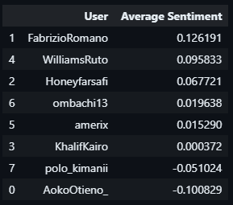

1. **Dependency Parsing and Keyword Sentiment**:

* After extracting keywords using dependency parsing, the user sentiment rankings slightly shifted, showing refined results:

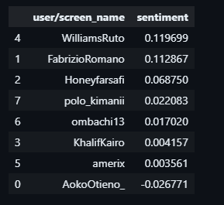

**Pre-processing Outputs**:

* The tweets were cleaned, tokenized, and lemmatized. For example:
  + Original tweet:  
    "Kenya and the US signed the Washington-Nairobi Vision Agreement"
  + Lemmatized:  
    ['Kenya', 'US', 'sign', 'Washington', 'Nairobi', 'Vision', 'Agreement']

1. **Key Phrase Sentiment**:
   * The sentiment scores derived from extracted keywords were closely aligned with the full text analysis, highlighting the effectiveness of dependency parsing in refining sentiment measurement.

**Conclusion**

The overall sentiment of the analyzed tweets is neutral to slightly positive, with some users consistently displaying more positive sentiment.

Refining the analysis using dependency parsing and keyword extraction provided more nuanced sentiment rankings.

Users such as FabrizioRomano and WilliamsRuto showed the highest average sentiment scores across both full-text and keyword-based analyses.